It should create a common understanding of what functions in the product are of most value to the end-customer. These functions should be visible at the top of the Anatomy. The Anatomy also visualises how the supporting functions relate to each other and to the “money making functions” that the customer is paying for. The relationship between functions of the product from a development point of you should be visualised. After the Anatomy data there should exist an Anatomy that is good enough to be used as the basis for a stable Integration Plan.

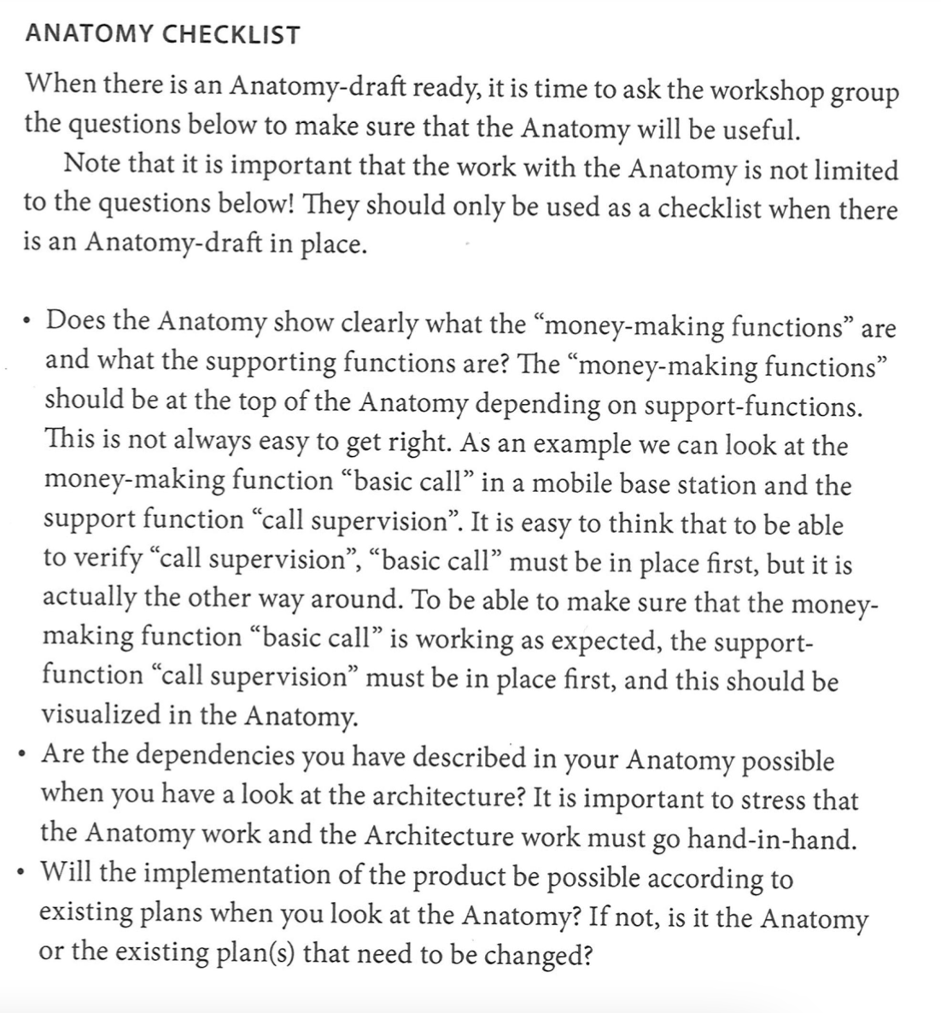

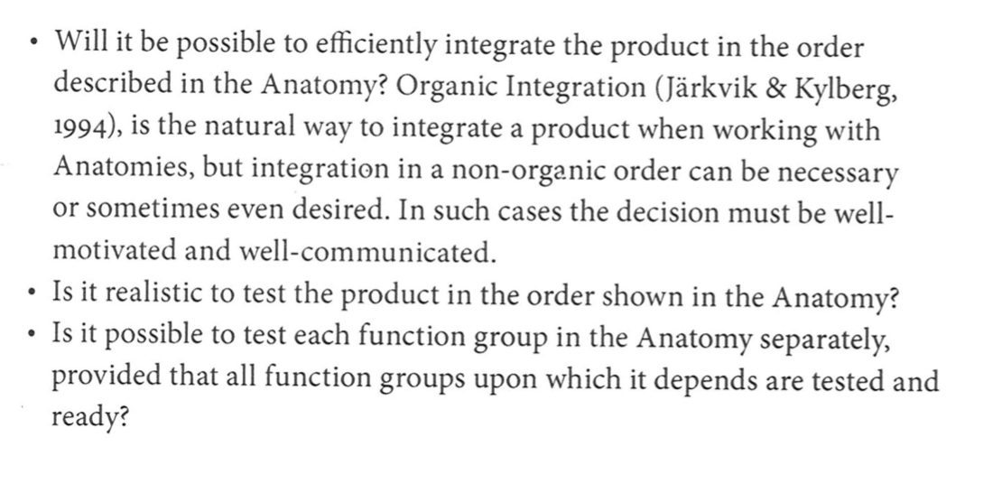

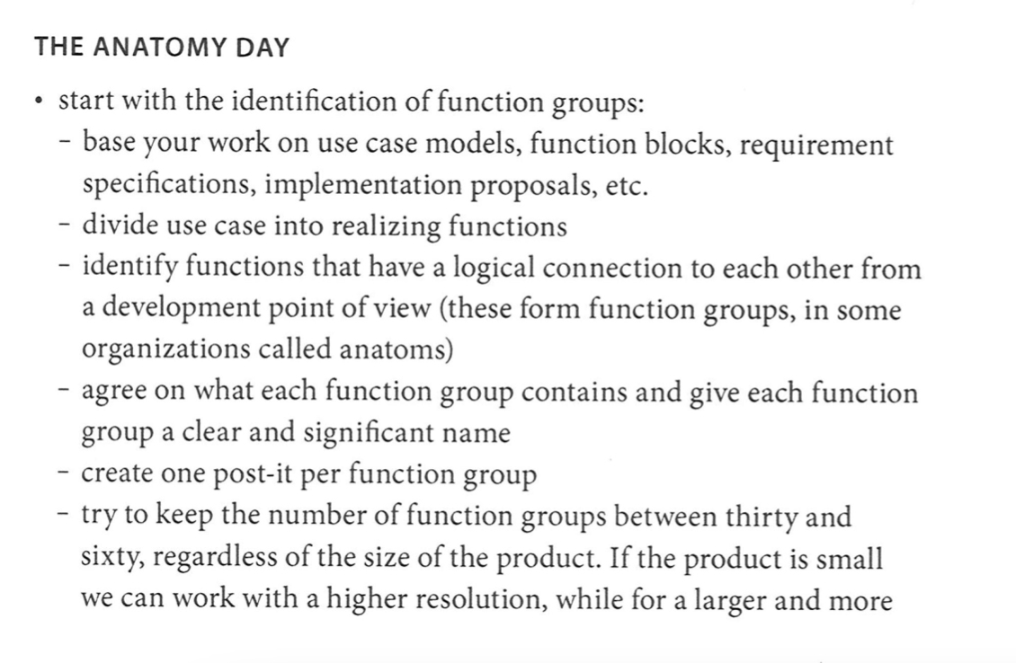

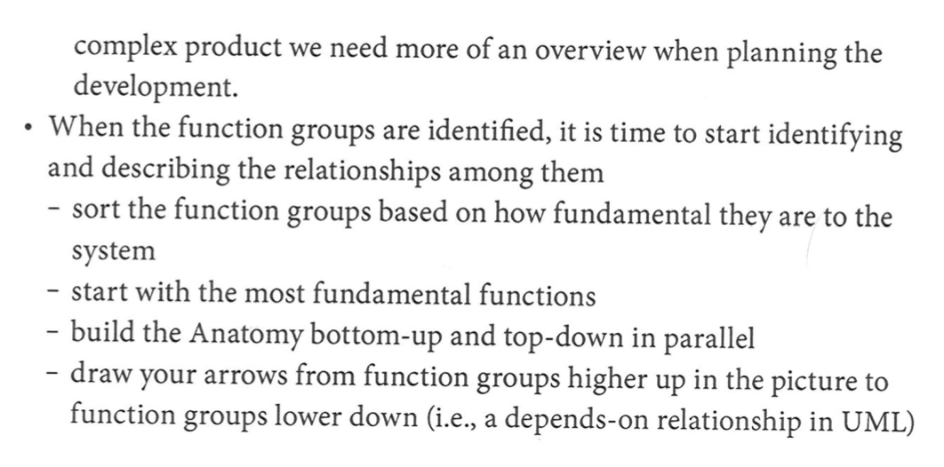

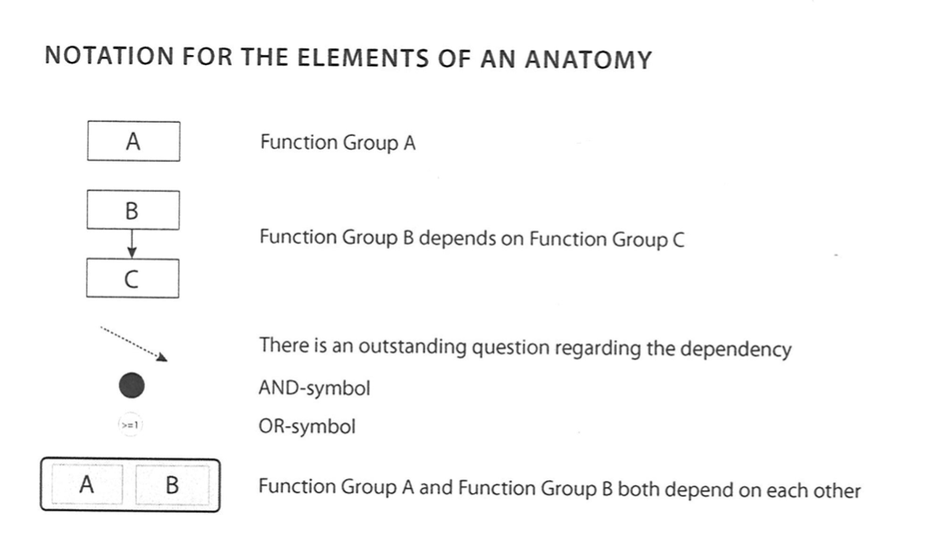

7a)

*Your system anatomy should have at least 15-20 different capabilities / anatoms (represented as boxes) including ones for services to users (“money-making”) and for system support such as start-up, configuration, supervision and error handling. Identify the technical relationships between the capabilities. Include the final version of the system anatomy in your report.*

**Front**

Lägga medlemmar

Utskick

Kommunikation

Teams - Medlemmsgrupper m.m.

Sökning

Fakturahantering/betalningar (OSS - WooCommerce)

For Statistik

Evenemang

Schemaläggning

**Back-end**

Admin -login

API- **integration med andra system**

Databas - kunduppgifter

Databas - fakturor/payment isch

Medlemmar

Betalningar

Schemaläggning

7b)

**Activity planning:**

*Identify the activities needed to develop your software based on the system anatomy, and the*

*dependencies between these. Consider which function groups in the anatomy that should be*

*split into several activities, see Taxén chapter 5. The activities should be detailed enough to*

*enable realistic and reliable cost estimates for the project. If helpful, produce a network-based*

*activity plan (logisk nätplan, Thonnqvist p.160-167).*

For example, we can start with user authentication. Which basically begins with creating a

Database for user registration, GUI for user signing up and signing in, some sort of

one/two factor authentication. Display what functionality can a user get after he/she

Authenticate himself/herself. This all could be one procedure done by one/two persons

At the same time.

Activities:

* **Implementing Member-page:**

Team-member 1 connects the member-page to the database so that every new member is added to the database.

Team-member 2 designs the GUI for the pages that are connected to the members.

* **Implementing the faktura-system**

Team-member 3 works on faktura-import function

Team-member 4 implements the function for sending fakturor

* **Implementing communication features:**

Team-member 5 works on creating communication features so that the styrelse can reach all the members.

* **Implementing the scheduling features:**

Team-member 6 works on adding event and scheduling functionality.

**Effort estimation:**

*Estimate the* ***effort and resource categories required for each activity*** *using a* ***suitable***

***estimation technique****. The estimates are to be realistic. For grades 4 & 5,   
the estimates need to be well motivated and not purely based on expert judgement.   
This can be done by using* ***PERT or poker planning*** *when estimating effort.   
Include information on* ***how estimates were done*** *in report.*

*Numbers, e.g. for PERT may be included in the appendix.*

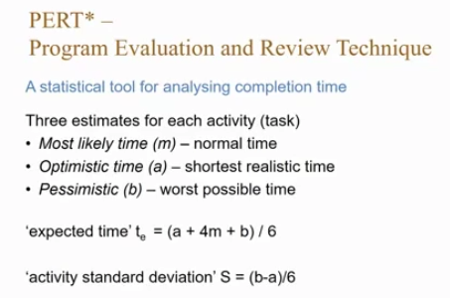

| **Aktivitet** | **Arbetsresurs** | **kapital** |
| --- | --- | --- |
| Projekt start |  |  |
| Implementera back-end |  |  |
| sätta upp databasen - connects the member-page to the database |  |  |
| Kommunikation (marknadsföring) |  |  |
| Implementera front-end - grundläggande GUI för hantering av viktigaste funktionalitet |  |  |
| Implementera i back-end inloggningar och hantera kontouppgifter |  |  |
| GUI for the pages that are connected to the members. |  |  |
| GUI - implements the function for sending fakturor |  |  |
| GUI? - communication features |  |  |
| adding event and scheduling functionality |  |  |

| **Kategori** | **Aktiviteter** | **Effort (m, a, b, t) arbetsdagar** |
| --- | --- | --- |
| **Front-end** |  |  |
| Medlemshantering | Overall | 14,9, 25, **15** |
|  | Lägga till och ta bort medlemmar | 5 |
|  | Design | 10 |
|  | Databas | 3 |
|  | Autentisering av medlemmar | 4 |
|  | Spara information | 3 |
|  |  |  |
| Kommunikation | Overall | 20,10, 35,**21** |
|  | Utskick i alla former typ event, betalning | 4 |
|  | Design | 10 |
|  | Databas koppling --> | 3 |
|  | Koppla till hemsidan hämta information | 6 |
|  | Spara information | 4 |
|  |  |  |
| Schemaläggning | Overall | 15,7, 20,**15** |
|  | Lägg till/Ta bort evenemang(<-tävling,träning,medlemträffar, mässor) | 5 |
|  | Databas koppling | 3 |
|  | Design/struktur på hemsidan | 10 |
|  | Koppling integration(kalender på mac, google kalender) | 15 |
|  |  |  |
| Fakturahantering | Overall | 20,10,45,**23** |
|  | Skicka fakturor/ Importera fakturor | 4 |
|  | Betala fakturor | 5 |
|  | Databas koppling | 4 |
|  | Design | 12 |
| <https://github.com/killbill/killbill> | Kill Bill <- OSS integration | 17 |
|  |  |  |
| **Back-end** |  |  |
| API-integration | Overall | 55,40,80,**57** |
|  | Möjlighet att integrera med andra tjänster som uppfyller funktioner vi inte uppfyller såsom fakturahantering (Visma?) | 20 |
|  | Design | 40 |
|  | Databas | 10 |
|  | Kontakt/kommunikation med andra företag | 40 |
|  | Tillgänglig software ? |  |
|  |  |  |
| Login | Overall | 30,15,60,**33** |
|  | Skapa login/mina sidor design | 17 |
|  | Datasäkerhet/Authentication(spara info i databas/begränsat gui) | 26 |
|  | Struktur/koppling med databas | 10 |
|  | Connect with payment? |  |
|  |  |  |
| Databas | Overall | 14,10,30,**16** |
|  | Sätta upp databas för medlemsregister | 4 |
|  | Sätta upp databas för Fakturor | 4 |
|  | Sätta upp databas för evenemang/schema | 4 |
|  | Sätta upp databas för utskick, kommunikation | 4 |
|  | Felhantering | 8 |
|  |  |  |
| Marknadsföring | Overall | 45,30,90,**50** |
|  | Reklam på sociala medier | 25 |
|  | Kontakta kommuner | 25 |
|  | Synas på mässor | 25 |
|  | Skicka uppdateringar | 25 |
|  | Säljstöd - bidrag | 25 |
|  | Säljstyrning |  |

7c)

**Effort estimation:**

* *See above...*

7d)

**Resource allocation:**

Identify your **resource needs** and **produce a resource list** (resursbehovsplan) that show how many resources are needed for each resource type/category for different time periods of the implementation project. Make realistic assumptions about the set of available resources **(e.g. based on cost; motivera lite i rapporten)** and allocated these resources to the activities. Does this introduce new dependencies?

Fanny - operativ chef

André - software developer och ekonomiansvarig

Emil - software developer

Sabah - designer, software developer och säljare

Lawand - software developer och marknadsföring

Amjad - UX/UI designer

| **Aktiviteter** | **Effort (m, a, b, t) arbetsdagar** | **Resource(who?)** | **K** |
| --- | --- | --- | --- |
|  |  |  |  |
| *Medlemshantering* | 14,9, 25, **15** |  |  |
| Lägga till och ta bort medlemmar |  | André |  |
| Design |  | Amjad, Sabah |  |
| databas | 2 | Emil, Lawand |  |
| Autentisering av medlemmar | 4 | Emil |  |
| Spara info |  | André |  |
|  |  |  |  |
| *Kommunikation* | 20,10, 35,**21** |  |  |
| Utskick i alla former typ event, betalning |  | Emil |  |
| Design |  | Amjad, Sabah |  |
| Databas koppling --> |  | Emil, Lawand |  |
| Koppla till hemsidan hämta information |  | Emil |  |
| Spara information |  | Emil, André |  |
|  |  |  |  |
| *Schemaläggning* | 15,7, 20,**15** |  |  |
| Lägg till/Ta bort evenemang(<-tävling,träning,medlemträffar, mässor) |  | André |  |
| Databas koppling |  | Emil, Lawand |  |
| Design/struktur på hemsidan |  | Amjad, Sabah |  |
| Koppling integration(kalender på mac, google kalender) |  | André |  |
|  |  |  |  |
| *Fakturahantering* | 20,10,45,**23** |  |  |
| Skicka fakturor/ Importera fakturor |  | Sabah |  |
| Betala fakturor |  | Sabah |  |
| Databas koppling |  | Emil, Sabah |  |
| Design |  | Amjad, Sabah |  |
| Killbill? <- THIS OSS integration |  | André, Emil |  |
|  |  |  |  |
|  |  |  |  |
| *API-integation* | 55,40,80,**57** |  |  |
| Möjlighet att integrera med andra tjänster som uppfyller funktioner vi inte uppfyller såsom fakturahantering (Visma?) |  | Emil, Sabah |  |
| design |  | Amjad |  |
| databas |  | Emil, Lawand |  |
| Koppling till andra tjänster |  | Emil |  |
| Kontakt/kommunikation med andra företag |  | Lawand |  |
| Tillgänglig software |  | Emil |  |
|  |  |  |  |
| *Login* | 30,15,60,**33** |  |  |
| Skapa login/mina sidor design |  | Amjad, Sabah |  |
| Datasäkerhet/Authentication(spara info i databas/begränsat gui) |  | André, Emil |  |
| Userfriendly - design |  | Amjad, Sabah |  |
| Struktur/koppling med databas |  | Emil, Lawand |  |
| Connect with payment |  | Emil |  |
| design |  | Amjad |  |
|  |  |  |  |
| *Databas* | 14,10,30,**16** |  |  |
| Sätta upp databas för medlemsregister |  | Emil, Sabah |  |
| Sätta upp databas för Fakturor |  | Emil, Sabah |  |
| Sätta upp databas för evenemang/schema |  | Emil, Sabah |  |
| Sätta upp databas för utskick, kommunikation |  | Emil, Sabah |  |
| Felhantering |  | Emil, Sabah |  |
| Funktionalitet |  | Emil, Sabah |  |
|  |  |  |  |
| *Marknadsföring* | 45,30,90,**50** |  |  |
| Reklam på sociala medier |  | Fanny, Lawand |  |
| Kontakta kommuner |  | Fanny, Lawand |  |
| Synas på mässor |  | Lawand |  |
| Skicka uppdateringar Lansering |  | Fanny, Lawand |  |
| Marketing |  | Lawand |  |
| Säljstöd - bidrag |  | Fanny, Lawand |  |
| Säljstyrning |  | Fanny, Lawand |  |
|  |  |  |  |

7e)

**Produce plan with milestones:**

Identify suitable increments for your plan by grouping of work packages, e.g. based on dependencies, resource limitations etc., and add milestones to represent these. Create your time plan. It should include dependencies, resources, milestones etc. and be placed in time, e.g. start and finish dates for each activity.

<https://try.wrike.com/web-based-gantt-chart-software/?ga_campaign=(ROI)+Timeline+-+EU&ga_adgroup=Project+Timeline&ga_keyword=project%20timeline%20online&targetID=kwd-25147507147&&cq_src=google_GOOGLE&cq_cmp=(ROI)+Timeline+-+EU_62182247&cq_med=71700000071540789_&cq_term=project%20timeline%20online_project+timeline+online&cq_net=g&cq_plac=&cq_plt=gp&cq_gclid=CjwKCAiAs92MBhAXEiwAXTi25wNxSES-AOi2BcSqvqIi5TxeK4JTdXNSVac1jnI96OXwAnIkeSExoRoCuOMQAvD_BwE&gclid=CjwKCAiAs92MBhAXEiwAXTi25wNxSES-AOi2BcSqvqIi5TxeK4JTdXNSVac1jnI96OXwAnIkeSExoRoCuOMQAvD_BwE&gclsrc=aw.ds>